Lightweight Tag

What is Lightweight Tag?
# Source: AI Source: Provided by: [Data Path: Persons Table -> ID Column: 1, Name_En Column: Motasem Essam] -> From: [ChatGPT] on [2/15/2026]
A lightweight tag is a simple pointer to a specific commit in your Git repository.
It’s called lightweight because it doesn’t store extra metadata like the tagger name, date, or message.
Think of it as a bookmark pointing to a commit.

Key points
# Source: AI Source: Provided by: [Data Path: Persons Table -> ID Column: 1, Name_En Column: Motasem Essam] -> From: [ChatGPT] on [2/15/2026]
- No extra information
  - Just a name pointing to a commit
  - Unlike annotated tags, no message or signature
- Does not move
  - Once created, it always points to the same commit
- Common use
  - Quick marking of a commit
  - Often temporary or for personal reference

How to create a lightweight tag
# Source: AI Source: Provided by: [Data Path: Persons Table -> ID Column: 1, Name_En Column: Motasem Essam] -> From: [ChatGPT] on [2/15/2026]

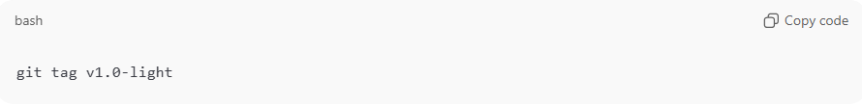
git tag v1.0-light
- This tag points to the current commit
- You can also tag a specific commit:
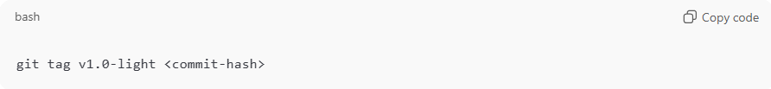
git tag v1.0-light <commit-hash>

How to view lightweight tags
# Source: AI Source: Provided by: [Data Path: Persons Table -> ID Column: 1, Name_En Column: Motasem Essam] -> From: [ChatGPT] on [2/15/2026]
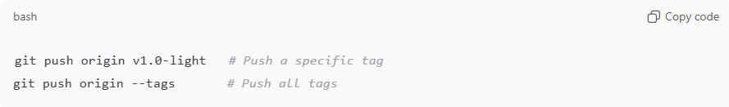
git tag # List all tags
git show v1.0-light # Show the commit it points to

How to push to remote
# Source: AI Source: Provided by: [Data Path: Persons Table -> ID Column: 1, Name_En Column: Motasem Essam] -> From: [ChatGPT] on [2/15/2026]
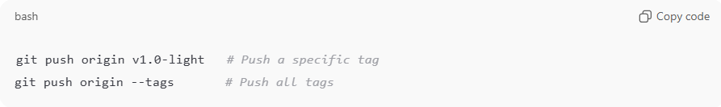
git push origin v1.0-light # Push a specific tag
git push origin --tags # Push all tags

Lightweight vs Annotated Tags
# Source: AI Source: Provided by: [Data Path: Persons Table -> ID Column: 1, Name_En Column: Motasem Essam] -> From: [ChatGPT] on [2/15/2026]
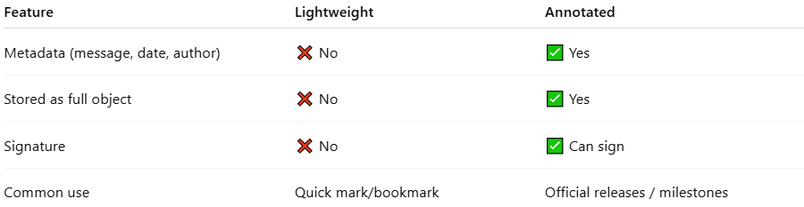
Feature | Lightweight | Annotated
Metadata (message, date, author) | ❌ No | ✅ Yes
Stored as full object | ❌ No | ✅ Yes
Signature | ❌ No | ✅ Can sign
Common use | Quick mark/bookmark | Official releases / milestones

💡 Memory trick:
# Source: AI Source: Provided by: [Data Path: Persons Table -> ID Column: 1, Name_En Column: Motasem Essam] -> From: [ChatGPT] on [2/15/2026]
Lightweight tag = sticky note/bookmark on a commit → simple and quick, no extra info ✅

